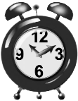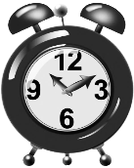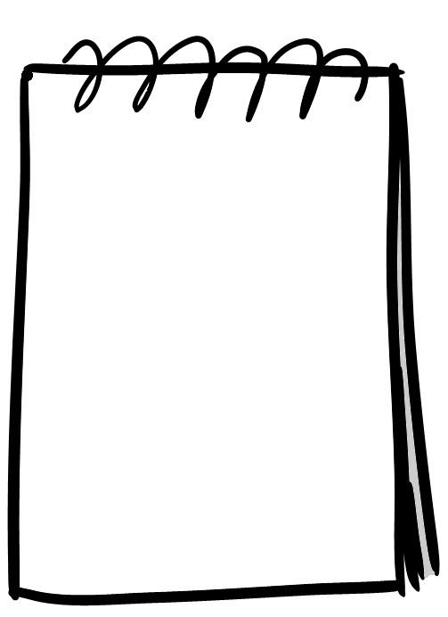



**Plan your time**

**Exam time: 60 minutes**

Break down the question

Plan your answer

Write introduction

Write main body

Write conclusion

Proofread your paper



|  |
| --- |
|  |