Cornell notes
Make notes on the right. Then, write the most important information in the key information section! Finally, try covering up the top sections of the page and writing a summary of your notes so you can check your understanding.

Key information | Notes: Maximum Efficiency of transformers
Efficiency formula:

Types of losses:

Equation for efficiency:

If input current is same as primary load current:

Maximum efficiency:
 | 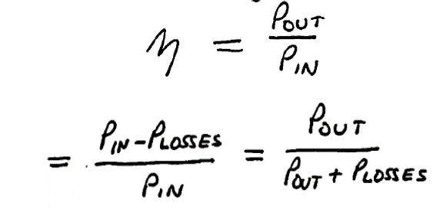
 | 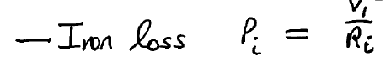
 | 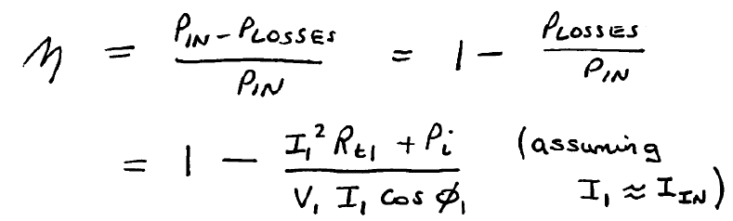
 | 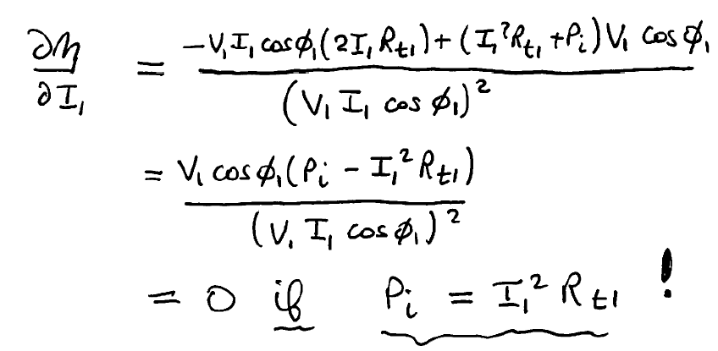
 | Summary
 | Efficiency is dependent on losses in the transformer which are of two types: Iron loss (fixed) and Copper loss (variable). Maximum efficiency can be calculated by differentiating efficiency equation w.r.t primary current. Maximum efficiency will occur when the load current produces copper losses in primary and secondary windings that have the same magnitude as the constant iron losses in the core.

