Consistent social structure and optimal clique size revealed by social network analysis of feral goats Capra hircus

Social network analysis has become a valuable tool for the measurement of social bonds and can give insight into the level of social complexity in a species. However, most studies have focussed on a single social group or community, and we have a rather limited understanding of the extent to which a species’ network structure varies across groups and across habitats. Here we investigate the strength and structure of social bonds in feral goat groups in two geographic locations that differ in ecological and climatic conditions. We show that a range of strengths of social bonds exist between female goats, with behavioural and spatial measures being highly correlated. We show that levels of aggression between spatially proximate individuals reflect the intrinsic costs of social living, but that lower rates between more strongly bonded individuals indicate a degree of social tolerance. We find consistent social structure despite differences in demography and ecology and propose that associations are driven by social benefits as well as by ecological requirements. We suggest that a clique size of 12-13 individuals may be optimal for goats; beyond this threshold, the system may be less stable and susceptible to fission.

Keywords: Capra hircus, dominance, goat, group living, social bonds, social network analysis
Social bonds between individuals are at the heart of the evolution and maintenance of social groups, yet have received relatively little attention from modern behavioural ecologists (Dunbar & Shultz 2010). Indeed the term “friendship” has only recently become generally accepted amongst primatologists (Silk 2002). Whilst a wealth of studies report strong social bonds between individuals belonging to a wide range of species (see Dagg 2011 for a review), we currently lack suitable indices to compare the nature and strength of these bonds both within and between species (Dunbar & Shultz 2010). It has been suggested that social network analysis might provide a key tool for addressing questions concerning the evolution of social organisation (Krause et al. 2007). We use it here in a single species, the feral goat (Capra hircus), across two populations and three social groups to investigate the nature of social bonds in this species.
Goats live in loose matrilineal social groups (heft groups), with levels of sexual segregation varying throughout the year due to sex differences in activity patterns and feeding requirements (Dunbar & Shi 2008). Three types of social group exist: female-only groups, male-only groups and mixed sex groups. Female-only groups are the most commonly observed (Shi et al. 2005). On average, the composition of a group changes approximately once an hour (Dunbar et al. 1990), hence fission or fusion events occur continually. Although there has been little research on social bonds in goats, there is some indication that social bonds do exist: Schino (1998) showed that, in domestic goats, reconciliation (measured by affiliative behaviour and proximity) occurred after experimentally induced conflicts. Such behaviour would only be expected where long term relationships which required repair existed in the first place. However, social vigilance levels in goats have been shown to be significantly lower than in both the well-bonded polygamous gelada baboon Theropithecus gelada and the monogamous klipspringer Oreotragus oreotragus (Dunbar & Shultz 2010); if social vigilance levels are a true measure of bondedness, goats would appear to score quite low. The key question is therefore this: are goat groups merely aggregations of individuals with similar nutritional demands, with individuals distributing themselves as a response to the shifting balance of the costs and benefits of group membership (Krause & Ruxton 2002)? Or are there preferred relationships which are maintained alongside other requirements?
In order to determine whether social bonds exist in goats and to assess their level of complexity, we used two behaviours (affiliative approaches and maintaining proximity) as indices of association. We also looked at displacement networks to investigate the costs associated with social bonds in goats: a more highly sociable individual may suffer from increased levels of aggression, which may be a key factor in the choice of spatial location in a group. To investigate optimal group size, we used the Girvan-Newman algorithm (which uses the “block modelling” approach, Girvan & Newman 2002) to define clusters within the network such that nodes are more closely connected within than between clusters. These can be compared across populations as any consistencies would be likely to be primarily due to social and not ecological factors. We also investigated whether individuals differed between clusters in terms of age or dominance rank.
Methods

Study Area and Animal Population
Data were collected from three feral goat heft groups in two locations (the Great Orme Country Park and Rum National Nature Reserve) located some 400km apart. The two habitats differ markedly in climate and vegetation. The Great Orme is situated on the northwest coast of Wales (53°2’N, 3°5’W). Its vegetation is mostly a mixture of open grass parkland and gorse thicket. The Isle of Rum (57°0’N, 6°20’W) lies off the northwest coast of Scotland and has been described in detail by Clutton-Brock & Ball (1987). It consists of a patchwork mosaic of vegetation communities, ranging from small grassy swards to nutrient-poor bog habitats. Being further north, the climate is more extreme on Rum: mean monthly temperatures varies between 4ºC and 14ºC on Rum (Dunbar & Shi 2008) and between 8ºC and 19ºC on Great Orme, with both rain and snowfall being considerably more common on Rum than Great Orme.
During the study period, there were approximately 100 goats in three heft groups on the Great Orme, and about 200 goats in 8-10 heft groups on Rum. The Rum goats are typical multi-coloured British wild goats; with the exception of a very small number of alpine males introduced later, they are the descendants of animals left behind on the island by the crofters when they emigrated to Canada in 1821. They are known to have been on the island since at least the 1770s. The Great Orme population is descended from half a dozen pure white Kashmir goats given to Queen Victoria by the Shah of Iran around 1905; there have been no introductions since. Every individual was identifiable by coat colour and pattern, and horn shape (Dunbar et al. 1990); in addition, the Great Orme females had been tagged with numbered plastic ear tags (though some of these had been lost). Age was determined by counting horn rings, since one ring is produced in each year of a goat’s life (Bullock & Pickering 1984). For most of the year, males and females are sexually segregated until the rut (late August to late September). Females give birth around late January and February.

Data Collection
The data were collected between September 2005 and September 2006 on Rum and between March 2006 and February 2007 on Great Orme. Data collection was restricted to daylight hours, since in northwest Europe, goats are only active during daytime (Shi et al. 2003). Only adult females, defined as those older than two years at the beginning of the study period, were sampled. All data were collected during 30-min focal animal samples during which all approaches and displacements involving the focal animal were recorded ad libitum (including the identity of the actors), and the identity of the focal’s nearest neighbour was sampled at 5-min intervals. The distance to this nearest neighbour was also estimated by eye. On Great Orme, the heft group almost always foraged as a single group (~35 animals, including kids and yearlings), whereas on Rum the heft group was invariably dispersed into several smaller foraging parties (mean size = 13.7±9.0 SD) reflecting the significantly poorer quality of the habitat on Rum. Mean distance to the nearest female neighbour was 4.03±4.08SD metres on Great Orme and 6.95±5.17SD metres on Rum. Heft groups were identified by ranging patterns: each heft group occupied a home range that overlapped only to a limited extent with those of neighbouring groups.
An approach was defined as one individual approaching to within one metre of another without displacing it; this was used as a measure of social tolerance. A displacement was defined as an approach that resulted in one of the individuals moving away immediately (in some cases, following a head butt). A total of 392 30-min focals (17.0±7.9SD per individual), along with 2823 nearest neighbour scans (122.7±52.4SD per individual), were obtained from 23 of the adult females of the Great Orme Artillery heft. Two heft groups were sampled on Rum: a total of 1083 focals (30.9±15.3SD per individual), along with 7338 nearest neighbour scans (209.7±118.8SD per individual), were obtained from the 35 females of the Rum Harris heft; and a total of 138 focals (6.0 ±5.0SD per individual), along with 828 nearest neighbour scans (36.0±29.9SD per individual) were obtained from the 23 females of the Rum GNP heft.

Network metrics and analyses
The behavioural indices used were approach rates, proximity rates and displacement rates; proximity rates were calculated using data from nearest neighbour scans, showing the rate at which a particular individual was found to be the focal individual’s nearest neighbour. Frequency data were converted into rates per hour for each dyad and were used to build a weighted network; the rates gave each tie (the line connecting two individuals, or nodes, in the network) a strength so, for example, individuals which approached each other more frequently were connected more strongly than those which rarely approached each other. Networks were built separately for each heft group. For the Rum GNP heft group, too few displacement events were recorded for a meaningful displacement matrix to be built. Network diagrams were produced using the program NetDraw version 2.118 (Borgatti 2002).
In order to determine whether individuals associated randomly or whether preferred associates existed, individuals’ degree centrality measures (Wasserman & Faust 1994) were calculated using the program “sna” (Butts 2010) within the “R” statistical environment (R Development Core Team 2008). The program “tnet” (Opsahl 2009) in R was then used to calculate the degree strength and closeness centrality of all individuals in weighted networks in order to investigate the individual centralities. Degree strength represents an individual’s gregariousness and is calculated by summing the weights of all edges directly connected to that individual’s node (Whitehead 2008). Closeness centrality reflects how close an individual is to other actors in the network and is calculated by taking the inverse of the sum of the geodesic distances from this actor to all other actors in the network (Wasserman & Faust 1994).
Displacements were used to determine individuals’ dominance ranks. Dominance indices were calculated for Great Orme and Rum Harris females using the program “steepness” (Leiva & de Vries 2011) in R. David’s scores (David 1988) were used as the dominance index. A Mantel test was used to test networks with identical actors for correlations, with 10,000 permutations run to generate P values appropriate to the network structures using the program “ade4” (Dray & Dufour 2007) in R.
To investigate differences in displacement rates between dyads with different relationship strengths (as measured by proximity rates), we carried out an RMA regression using the program “lmodel2” (Legendre 2011) in R. We used the results from this analysis to calculate dyadic residual values. We used Pearson correlation to examine the relationship between proximity rate and this residual.
To test for consistency of Great Orme and Rum Harris individuals’ strength and closeness centrality scores across three networks, we ranked each individual within their heft in terms of strength/closeness. This was carried out for each network separately. We then used the program “irr” (Gamer 2010) in R to calculate the Intraclass Correlation Coefficient (ICC) (Bartko 1966).
The Girvan-Newman algorithm (Girvan & Newman 2002) within the program NetDraw version 2.118 (Borgatti 2002) was used to assign individuals to clusters. The optimal number of clusters is defined by the algorithm as that with the highest Q score. Individuals which were consistently assigned to the largest cluster across all three networks were assigned to the “core” subgroup, with other individuals being assigned to the “non-core” subgroup. We then tested for a difference between these individuals’ centrality scores, grouping them as either “core” or “non-core”, by using a t test . We used the same procedure to test for differences in dominance level and age between core and non-core females.

Results

Affiliative networks
Two association indices were used to build weighted affiliative networks: approach rates and proximity rates. For each of the three heft groups, networks for these two indices were significantly correlated (Great Orme: Mantel test z = 0.355, P<0.001, Fig. 1a,b; Rum Harris: Mantel test z = 0.854, P<0.001, Fig. 2a,b; Rum GNP: Mantel test z = 0.619, P<0.001, Fig. 3a,b).

Displacement networks
For the two heft groups where displacement rate data were available, this network significantly correlated with both types of affiliative network. For the Great Orme heft group, the displacement rate network (Fig. 1c) was significantly correlated with the approach rate (Mantel test z = 0.315 , P<0.001) and proximity rate (Mantel test z = 0.432 , P<0.001) networks. The same was also the case for the Rum Harris heft group (Fig. 2c) (approach rate: Mantel test: observed z = 0.227, P<0.01; proximity rate: Mantel test z = 0.353, P<0.001).
However, dyads differed in their levels of aggression according to the strength of their relationship. An RMA regression with 99 permutations was used to calculate residuals for each of the two heft groups (Great Orme: intercept = -0.0519, slope = 0.449, P-perm = 0.01; Rum Harris: intercept = -0.0325, slope = 0.319, P-perm = 0.01). These residuals were plotted against the proximity rate for each dyad, which was used as a measure of relationship strength (Fig. 4a, b). Residuals were significantly negatively correlated with proximity rates (Pearson correlations: Great Orme, N = 253, c = -0.760, P < 0.001; Rum Harris, N = 595, c = -0.778, P < 0.001).

Network substructure
The Girvan-Newman algorithm, used to determine clusters within a network, found that the Great Orme heft group was best split into one main group with 5 outliers (Q = 0.02) based upon the approach rate network (Fig. 1a), 7 outliers (Q = 0.021) based upon the proximity rate network (Fig. 1b) and 9 outliers (Q = 0.018) based upon the displacement rate network (Fig. 1c). Four individuals were consistently outliers across all three networks, whilst another two were outliers in both proximity and displacement networks. 12 individuals were consistently found to be in the core group across all networks; despite the core groups based on the three types of data varying in the absolute number of animals, the identity of 12 individuals was constant across these networks’ core groups.
The Rum Harris heft group was best split into one main group, with 13 outliers (Q = 0.022) based on the approach rate network (Fig. 2a), 17 outliers (Q = 0.017) based on the proximity rate network (Fig. 2b) and 19 outliers (Q = 0.053) based on the displacement rate network (Fig. 2c). Eleven individuals were consistently outliers across all three networks, whilst another three were outliers in both proximity and displacement networks, with one appearing in both approach and displacement networks. 13 individuals were consistently found to be in the core group across all three networks.
The Rum GNP heft group was best split into four subgroups (Q = 0.348) based on the approach rate network (Fig. 3a) and into one main group with 9 outliers (Q = 0.032) based on the proximity rate network (Fig. 3b). Individuals which were outliers in the proximity network were distributed quite evenly across the subgroups identified in the approach network. The first would imply a core group of 12 females, the second four core groups averaging six females each. However, the small number of approaches sampled probably makes the latter value less reliable than that based on nearest neighbour data, for which the sample size was much (~7 times) larger.

Core versus peripheral females
Individuals’ ranked strength and closeness centrality measures both correlated significantly across the approach rate, proximity rate and displacement rate networks for each of the two main heft groups (Great Orme: strength, ICC=0.665, F_{22,46}=6.94, P<0.001; closeness, ICC=0.578, F_{22,46}=5.11, P<0.001; Rum Harris: strength, ICC=0.32, F_{34,70}=2.41, P<0.001; closeness, ICC=0.319, F_{22,46}=2.40, P<0.001). The individuals which were consistently assigned to the core group by the Girvan-Newman algorithm were significantly more central (in terms of closeness centrality in the proximity network) than the other heft group members for both Great Orme (t test: N = 23, t₂₁ = 4.880, P < 0.001; Fig. 5a) and Rum Harris (t test: N = 35, t₃₃ = 3.758, P = 0.001; Fig. 5b).
The females assigned to the core group did not differ significantly in dominance level to other heft group members for either Great Orme (t test: N = 35, t₂₁ = 1.549, P = 0.136) or Rum Harris (t test: N = 35, t₃₃ = 0.063, P = 0.950). Nor did the core females differ in age from the more peripheral heft members for either the Great Orme heft (t test: N = 21, t₁₉ = 0.494, P = 0.627) or the Rum Harris heft (t test: N = 28, t₂₆ = -0.496, P = 0.624).

Discussion

It is clear that goats do not associate randomly but have preferred social partners, with the strength and number of these associations varying across individuals. Approach and proximity networks are significantly correlated; displacement networks also correlate with each of these affiliative networks. However, dyads with stronger bonds engage in significantly less aggression than expected. In each heft group, there appears to be a core group of 12-13 individuals who form a distinct clique; this clique size is consistent both across the three network types and across all heft groups. More importantly, this core grouping appears to be independent of the quite significant difference between the three heft groups in ecology, climate, demographic structure and genetic origin, suggesting that this may be a fixed characteristic of goats as a whole. Individuals belonging to this clique are of significantly higher centrality than other heft members, but do not differ in either dominance rank or age.
In all three heft groups, the social networks based upon approach rates and proximity rates correlated significantly. Perhaps more surprisingly, a significant correlation was found between the displacement rate network and each of the approach and proximity rate networks for the two hefts for which there was a sufficient sample of displacements. The proximity networks capture the identity of an individual’s nearest neighbour across multiple snapshots of time, indicating which individuals are consistently found close to each other. This index alone does not necessarily measure social bonds; it could be that individuals with similar nutritional demands associate together, as has been found for example in Grevy’s zebra Equus grevyi (Sundaresan et al. 2007). Approach networks, in contrast, do indicate the active servicing of social bonds, with one individual seeking out another and choosing to maintain proximity with it; they also imply social tolerance, since no displacement occurs following the approach. The fact that these two networks correlate shows not only that active maintenance of relationships is occurring, but that individuals choose to maintain proximity with preferred partners over time, since the proximity scans are picking up the same pattern of social bonds as the behavioural measures. This allows us to draw two conclusions about social bonds in goats: that preferred partners are actively sought out and that individuals choose to maintain proximity over time with their preferred partners.
This conclusion notwithstanding, the positive correlation between the displacement rate network and each of the approach and proximity networks shows that levels of aggression are higher between individuals which spend time in relatively close proximity to each other. This implies an obvious cost to sociality and to maintaining proximity with particular individuals. This cost may of course vary seasonally as forage changes in availability and quality (Gordon 1989a, b). However, this was not tested here. Nonetheless, when residuals from the regression of dominance interaction rate against proximity rate are analysed, it becomes clear that the dyads with the strongest relationships (i.e. with the highest rate of proximity) also have the most negative residuals, showing these dyads are engaging in significantly fewer aggressive interactions than are those with weaker relationships. This result shows that strong relationships exist between particular individuals where higher tolerance of proximity results in fewer aggressive interactions.
Further examination of the correlations between approach and proximity networks can enable us to further separate out ecologically driven associations from those which are more socially mediated. Approach behaviour is the mechanism which drives the maintenance of proximity between individuals, since an approach which does not result in aggression or displacement results in two individuals being neighbours; thus the approach network in essence drives the proximity network and hence the two are significantly correlated. However the strength of the correlation can give us an insight as to how amicable the relationship is. If associations were mainly driven by ecology, we would expect that in an environment where food is of poorer quality and hence foraging competition is greater, the correlation between the approach and proximity networks would be weaker due to decreased social tolerance. In this study, Rum is the poorer quality habitat and therefore we would expect the correlation between these networks to be lower in the two heft groups sampled here. However, our results show that the z values for the Rum hefts are actually both higher than that found for the Great Orme heft (see “Affiliative networks” section in Results), demonstrating there is actually a stronger correlation between approach and proximity networks in the poorer quality habitat. This result gives us a good indication that ecology may not be the major determinant of social structure, but that associations may have social benefits.
In “socially complex” species, such as primates, relationships with different individuals may be multi-layered, based on a number of emotional components (Fraser, Schino & Aureli 2008). In these species, we would not necessarily expect networks based upon various indices to correlate since the different types of relationships exist for different purposes. For example, a relationship which is the basis of a coalition between females may be of a very different nature to that between two individuals which cooperate in foraging tasks, which would be reflected in social networks based upon specific association indices. Our data for the goats do not provide any evidence for such a level of complexity in relationships; rather, we have shown that simple relationships between individuals exist where proximity is maintained with a preferred companion, where both individuals allow this proximity to persist over time. The benefits of such relationships are unclear, but social relationships could perhaps provide a benign environment in which to raise young, increasing reproductive success, as has been shown in horses (Cameron et al. 2009). These relationships are not totally straightforward though: a range of strengths exist, with some level of aggression also occurring between partners. It may be that displacements continue to exist alongside affiliative relationships in order to maintain the heft’s social hierarchy. This would imply that goats must be cognitively able to perceive an individual as both a social partner and a potential competitor; processing both these identities concurrently implies there is some degree of complexity of social interactions in goats.
Despite living in quite different habitats and foraging group sizes, as well as the number of females studied being vastly different (23 in Great Orme vs. 35 in Rum Harris), the number of individuals always appearing in the core group across the three correlated networks for both the Great Orme and Rum hefts was highly consistent at 12-13 in all three hefts. These individuals were also found to be significantly more central in the overall network. We interpret this as the maximum number of relationships that individual goats are capable of maintaining. When a heft exceeds this size, cohesion (and hence, perhaps, stability) decreases and the likelihood of group fission increases (see Calhim et al. 2006, Dunbar & Shi 2008).
Individuals differ consistently across the affiliative networks with respect to their relative positioning; in all three hefts, certain individuals were consistently outliers. In terms of spatial positioning, being on the edge of a social group may carry higher risk of predation. More importantly, these individuals are socially less central and so have fewer social bonds, which may impact upon their reproductive success (Cameron et al. 2009). There are a number of possible explanations for these individuals’ peripheral positioning. One may be that, once group exceeds the optimal size, additional individuals are relegated to the periphery due to social pressure and lower competiveness. These individuals may be in a position where they are ready to disperse to create a new heft group, but cannot do so until a number of others are willing to go with them so as to form a heft of sufficient size to provide protection from predators (c.f. Bettridge & Dunbar in press). Indeed, the Harris heft group itself did not exist before 1983, but came into existence sometime between 1983 and 2000 as a result of emigrations from adjacent hefts.
However, it is important to note that, despite being peripheral, these individuals can nonetheless have preferred relationships: for example, individuals O9 and O10 in the Great Orme heft (Fig. 1a,b) have a relatively strong bond in both approach and proximity networks, but, significantly, not in the displacement network (Fig. 1c). An alternative explanation might thus be that the peripheral individuals are merely employing an alternative strategy of staying out of the central melee of aggression. These individuals may miss out on some of the benefits of having a larger number of social bonds, but benefit from lower aggression levels. It would be interesting to determine whether there is a difference in reproductive fitness between core and non-core individuals; this might elucidate whether or not this is a viable alternative strategy, or just one adopted by less competitive individuals.
It may be that relatedness plays an important role in structuring goat social groups (Gordon et al. 1987). Core individuals may belong to a particular matriline; this would explain the overlap in ages and dominance ranks between the core and non-core groups. However, until we have genetic data available, we are unable to test this hypothesis.
To conclude, in this paper we have shown some degree of social complexity in goats. A range of strengths of bond exist, with females showing clear preferences for maintaining proximity with certain individuals. We have shown that these social bonds are actively maintained and permitted by both parties. Although more strongly bonded dyads show a lower frequency of dominance interactions, aggression is more frequent between neighbours than between individuals who are rarely found together. This implies that aggressive interactions are a clear cost to social life in goat hefts, with some individuals preferring to minimise these costs by gravitating to the periphery of the network. Peripheral individuals avoid some aggression but pay the cost of having fewer or weaker social bonds, as well as being more exposed to the risk of predation. We suggest that a group size of 12 or 13 individuals may be optimal for goats, perhaps due to cognitive or behavioural constraints; where the group size is consistently larger, fission may be predicted as bonds become less stable. We propose that associations in goats are not merely driven by ecology, but that they also have some social benefits which we do not yet fully understand.
References

Bartko, J. J. 1966. The intraclass correlation coefficient as a measure of reliability. Psychological Reports, 19, 3-11.
Bettridge, C. & Dunbar, R. In press. Perceived risk and predation in primates: predicting minimum permissible group size. Folia Primatologia, 83.
Borgatti, S. P. 2002. NetDraw: Graph Visualization Software. Harvard: Analytic Technologies. https://sites.google.com/site/netdrawsoftware/download
Bullock, D. J. & Pickering, S. P. 1984. The validity of horn ring counts to determine the age of Scottish feral goats (Capra-domestic). Journal of Zoology, 202, 561-564. Butts, C. T. 2010. sna: Tools for Social Network Analysis. http://erzuli.ss.uci.edu/R.stuff
Calhim, S., Shi, J. B. & Dunbar, R. I. M. 2006. Sexual segregation among feral goats: testing between alternative hypotheses. Animal Behaviour, 72, 31-41.
Cameron, E. Z., Setsaas, T. H. & Linklater, W. L. 2009. Social bonds between unrelated females increase reproductive success in feral horses. Proceedings of the National Academy of Sciences of the United States of America, 106, 13850-13853.
Clutton-Brock, T. H. & Ball, M. E. 1987. Edinburgh Island Biology Series; Rhum: The Natural History Of An Island. Edinburgh: Edinburgh University Press.
Dagg, A. I. 2011. Animal Friendships. Cambridge: Cambridge University Press.
David, H. A. 1988. The Method of Paired Comparisons. London: C. Griffin.
Dray, S. & Dufour, A. B. 2007. The ade4 package: implementing the duality diagram for ecologists. Journal of Statistical Software, 22, 1-20. http://cran.r-project.org/web/packages/ade4/index.html
Dunbar, R. I. M., Buckland, D. & Miller, D. 1990. Mating strategies of male feral goats - a problem in optimal foraging. Animal Behaviour, 40, 653-667.
Dunbar, R. I. M. & Shi, J. 2008. Sex differences in feeding activity results in sexual segregation of feral goats. Ethology, 114, 444-451.
Dunbar, R. I. M. & Shultz, S. 2010. Bondedness and sociality. Behaviour, 147, 775-803.
Fraser, O. N., Schino, G. & Aureli, F. 2008. Components of relationship quality in chimpanzees. Ethology, 114, 834-843.
Gamer, M. L., Jim; Fellows, Ian; Singh, Puspendra. 2010. irr: Various Coefficients of Interrater Reliability and Agreement. http://cran.r-project.org/web/packages/irr/index.html
Girvan, M. & Newman, M. E. J. 2002. Community structure in social and biological networks. Proceedings of the National Academy of Sciences of the United States of America, 99, 7821-7826.
Gordon, I. J. 1989a. Vegetation community selection by ungulates on the Isle of Rhum. I. Food supply. Journal of Applied Ecology, 26, 35-51.
Gordon, I. J. 1989b. Vegetation community selection by ungulates on the Isle of Rhum. II. Vegetation community selection. Journal of Applied Ecology, 26, 53-64.
Gordon, I. J., Dunbar, R., Buckland, D. & Miller, D. 1987. Ponies, cattle and goats. In: Rhum: The Natural History of an Island (Ed. by T. Clutton-Brock & I. Ball), pp. 110-125. Edinburgh: Edinburgh University Press.
Krause, J., Croft, D. P. & James, R. 2007. Social network theory in the behavioural sciences: potential applications. Behavioral Ecology and Sociobiology, 62, 15-27.
Krause, J. & Ruxton, G. D. 2002. Living in groups. Oxford: Oxford University Press.
Legendre, P. 2011. lmodel2: Model II Regression. http://cran.r-project.org/web/packages/lmodel2/index.html
Leiva, D. & de Vries, H. 2011. Steepness: Testing Steepness of Dominance Hierarchies. http://cran.r-project.org/web/packages/steepness/index.html
Opsahl, T. 2009. Structure and Evolution of Weighted Networks. Ph.D. thesis, University of London, Queen Mary College. http://toreopsahl.com/publications/thesis/
R Development Core Team. 2008. R: A language and environment for statistical computing. Vienna, Austria: R Foundation for Statistical Computing. http://cran.r-project.org
Schino, G. 1998. Reconciliation in domestic goats. Behaviour, 135, 343-356.
Shi, J. B., Dunbar, R. I. M., Buckland, D. & Miller, D. 2003. Daytime activity budgets of feral goats (Capra hircus) on the Isle of Rum: influence of season, age, and sex. Canadian Journal of Zoology-Revue Canadienne De Zoologie, 81, 803-815.
Shi, J. B., Dunbar, R. I. M., Buckland, D. & Miller, D. 2005. Dynamics of grouping patterns and social segregation in feral goats (Capra hircus) on the Isle of Rum, NW Scotland. Mammalia, 69, 185-199.
Silk, J. B. 2002. Using the'F'-word in primatology. Behaviour, 139, 421-446.
Sundaresan, S. R., Fischhoff, I. R., Dushoff, J. & Rubenstein, D. I. 2007. Network metrics reveal differences in social organization between two fission-fusion species, Grevy's zebra and onager. Oecologia, 151, 140-149.
Wasserman, S. & Faust, K. 1994. Social Network Analysis: Methods and Applications (Structural Analysis in the Social Sciences). Cambridge: Cambridge University Press.
Whitehead, H. 2008. Analysing Animal Societies. Chicago: Chicago University Press.

Figure Legends

Figure 1
Weighted social networks of Great Orme heft group based on (a) approach rates, (b) proximity rates and (c) displacement rates. Red nodes are individuals in the main central group whilst other coloured nodes are outliers, as determined by the Girvan-Newman algorithm. Thickness of lines represents strength of ties between nodes, with thicker lines indicating stronger ties.

Figure 2
Weighted social networks of Rum Harris heft group based on (a) approach rates, (b) proximity rates and (c) displacement rates. Blue nodes are individuals in the main central group whilst other coloured nodes are outliers, as determined by the Girvan-Newman algorithm. Thickness of lines represents strength of ties between nodes, with thicker lines indicating stronger ties.

Figure 3
Weighted social networks of Rum GNP heft group based on (a) approach rates and (b) proximity rates. Colours of nodes represent subgroups, as determined by the Girvan-Newman algorithm. Thickness of lines represents strength of ties between nodes, with thicker lines indicating stronger ties.

Figure 4
Residuals plots with best fit lines illustrating significant correlations between RMA residuals & proximity rates for (a) Great Orme and (b) Rum Harris. The higher the neighbourhood rate, i.e. the more frequently individuals are neighbours, the more strongly negative the residual.

Figure 5
Boxplots showing spread of closeness centrality values for individuals belonging to (a) the Great Orme and (b) Rum Harris heft groups based upon the proximity rate networks. The box plots show the median and 25th and 75th percentiles; the whiskers indicate the values within 1.5 times the interquartile range, IQR.

Figures

Figure 1
(a)
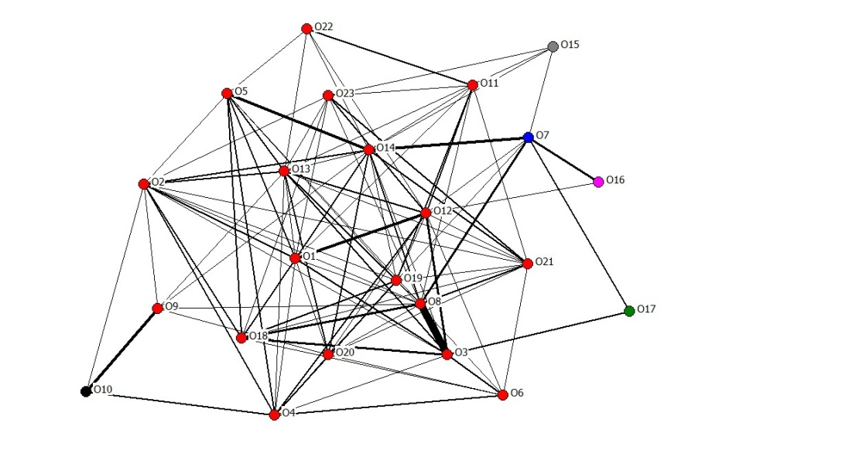

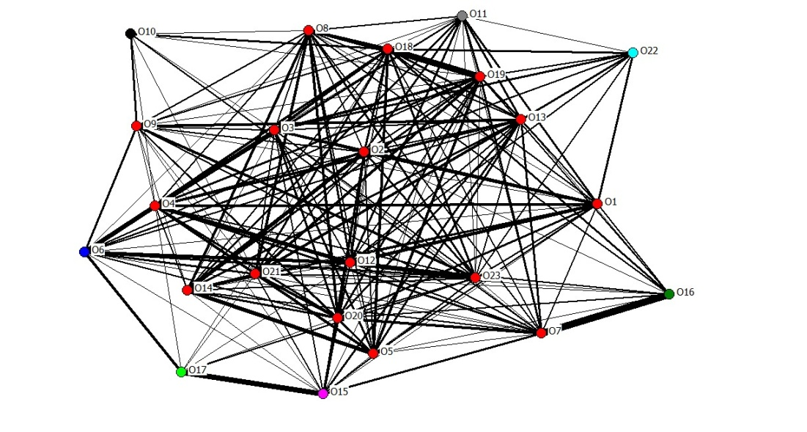
(b)

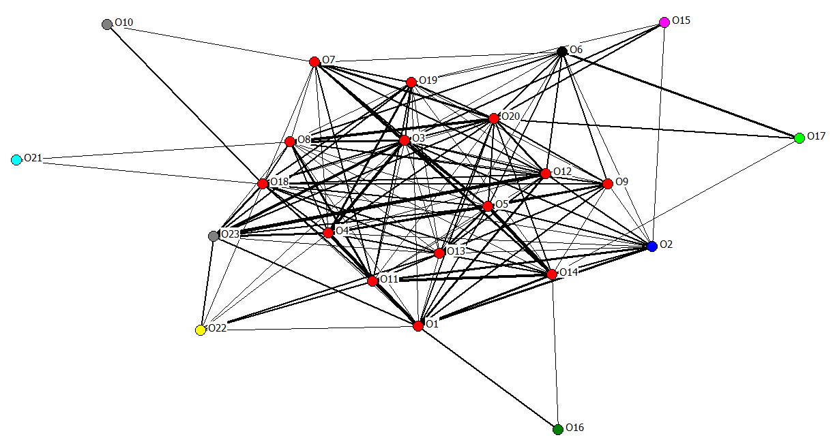
(c)

Figure 2
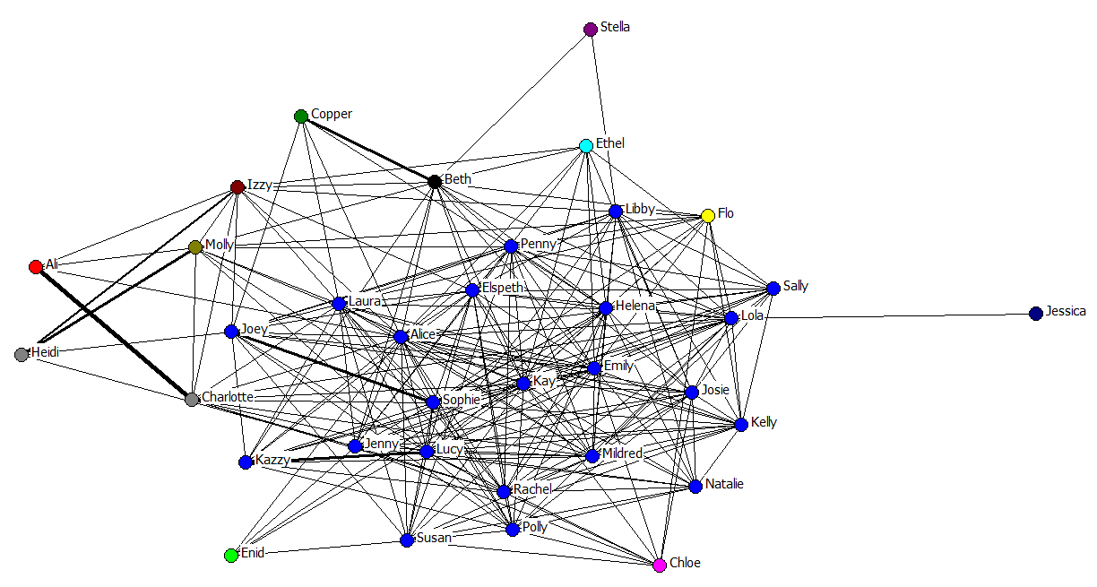
(a)

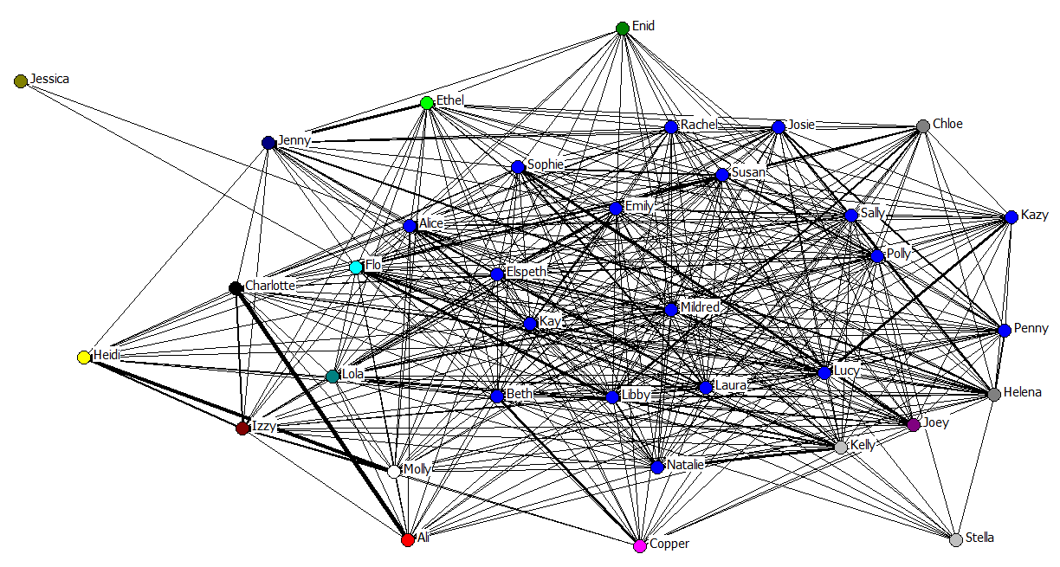
(b)

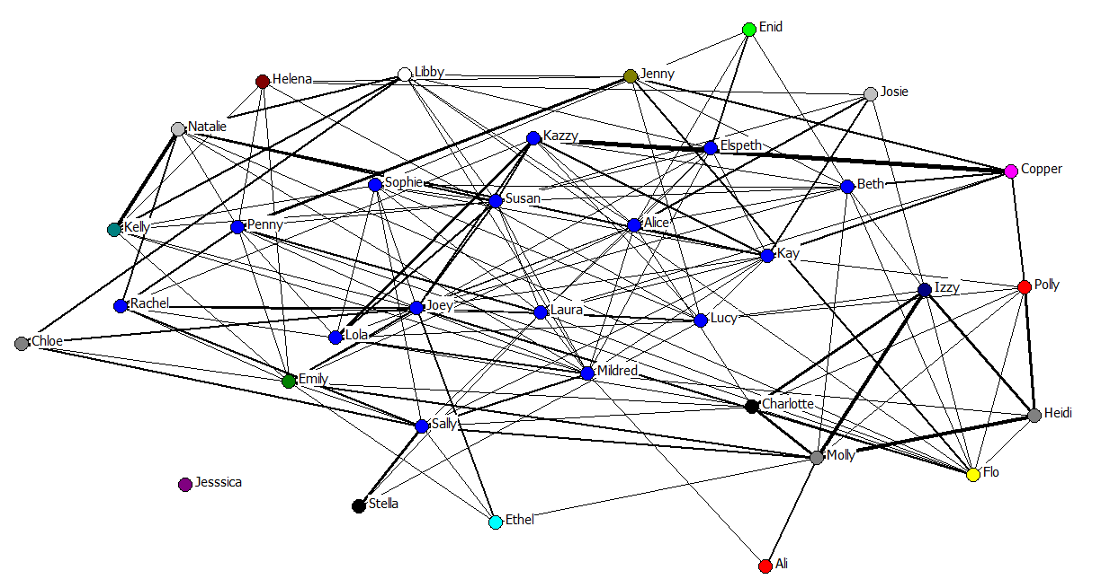
(c)

Figure 3
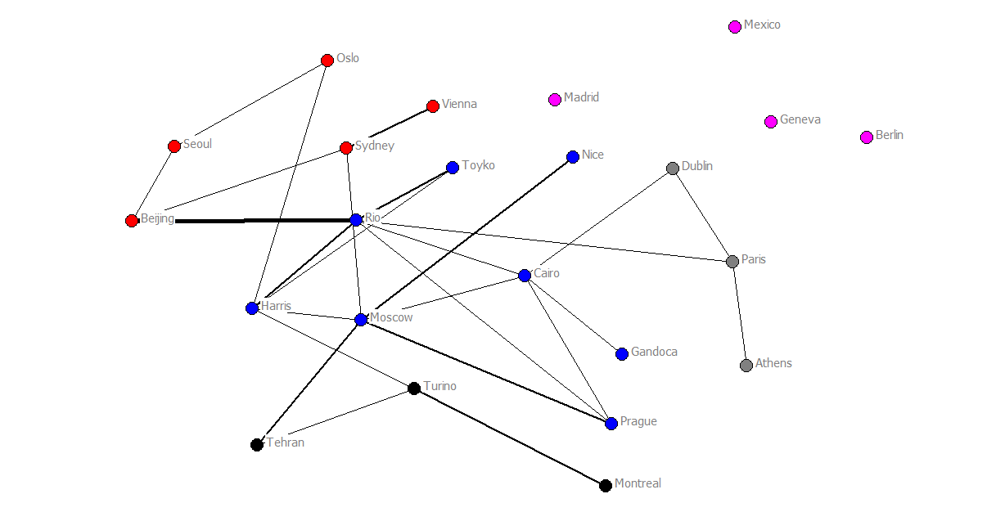
(a)

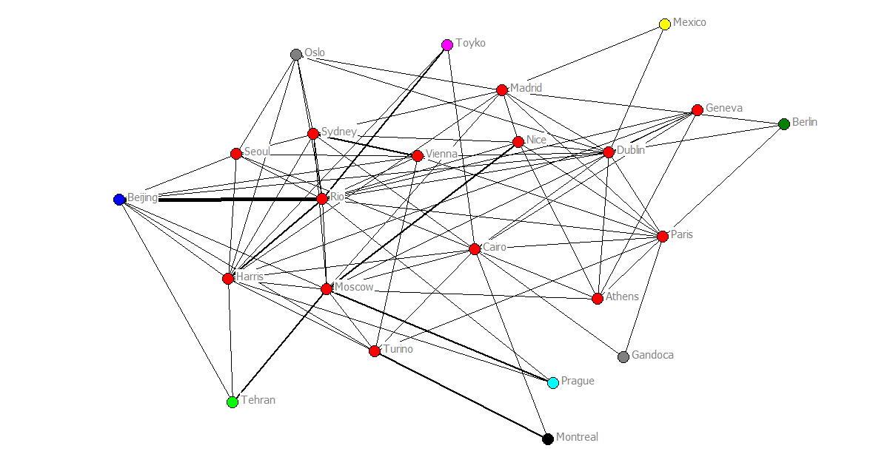
(b)

Figure 4
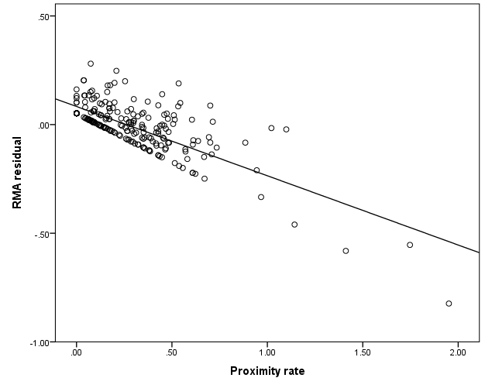
(a)

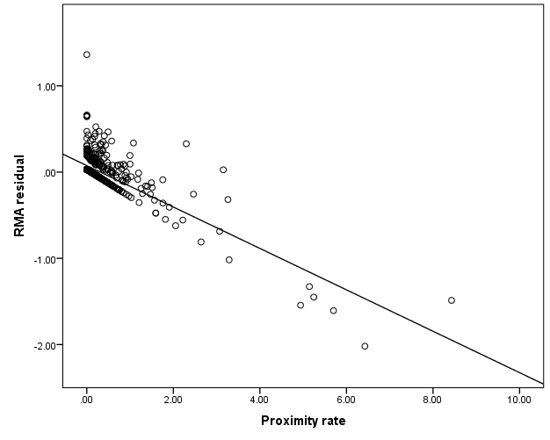
(b)
Figure 5

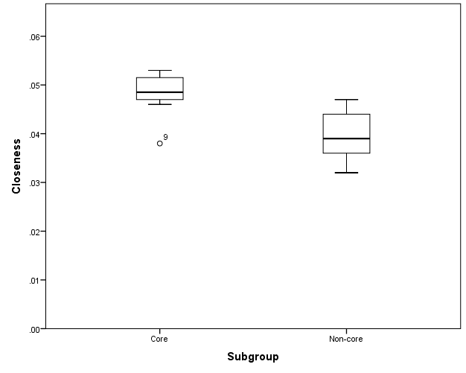
(a)

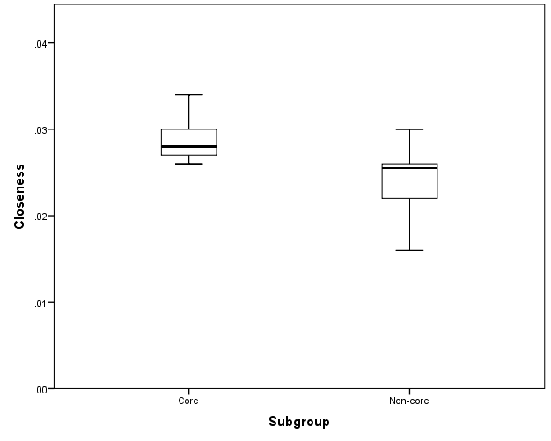
(b)

